

Customer Advance Ship Notice

(ASN)

Internal Onboarding Guide

# Table of Contents

Table of Contents 2

Document control 3

Purpose 3

Overview 3

Related Documents 3

Context Diagram 4

ASN Delivery 5

eMail Notification 5

ASN Download 6

ASN Information & Documents 9

Shipping Labels 10

Parcel Carriers 10

LTL Carriers 11

# Document control

|  |  |  |
| --- | --- | --- |
| Version | Date | Description |
| 1 | 20190913 | Draft |

# Purpose

The purpose of this document is to be an internal guide for onboarding customers to the ASN process. It is intended to be used to train customers on the process.

# Related Documents

|  |  |
| --- | --- |
| Name | Note |
| [Customer ASN Technical Implementation Guide 9-9-2019 V1.0](http://pmo.bcldb.com/corporate/project/Cannabis%20Program/Cannabis%2020/Z.%20ASN%20Outbound%20Cannabis%20B2B/FINAL%20DOCS/Customer%20ASN%20Technical%20Implementation%20Guide%209-9-2019%20V1.0.docx) | Current release version of technical implementation guide. |
| [Customer ASN Technical Implementation Guide 9-9-2019 V2.0](http://pmo.bcldb.com/corporate/project/Cannabis%20Program/Cannabis%2020/_Analysis%20Documents/CAN-1198%20ASN%20for%20B2B%20Outbound%20Orders%20(Epic)/Customer%20ASN%20Technical%20Implementation%20Guide%209-9-2019%20V2.0.docx) | This is version two of the implementation guide. As of the writing of this document, this version has not been released to the customers. |

# Overview

For every shipment sent to the customer, BC Cannabis Wholesale will create an ASN. The ASN will be available in two formats (XML Data and Human Readable PDF). Both formats will be created and be available for download from BC Cannabis Wholesale’s ASN web site via Secure File Transfer Protocol (sFTP) after the shipment leaves the BC Cannabis LDB’s cannabis distribution centre.

The ASN replaces the packing slip previously accompanying each shipment. It is the customer’s responsibility to retrieve the ASN from the BC Cannabis Wholesale ASN website.

The following section will explain the format and delivery of the XML data version of the ASN.

This document explores:

* Onboarding Process
* ASN Messaging Context
* ASN Delivery
* ASN Information & Receiving Documents

# Onboarding Process

## Talend Settings

The table below illustrates the Talend settings to be used to manage ASN notifications to customers during pilot and rollout phases. Post roll-out, all new customers will be set to XML;PDF;EMAIL;

|  |  |  |  |
| --- | --- | --- | --- |
|  | **Start** | **Pilot Phase** | **Roll-Out Phase** |
| **Pilot**  **Customers** | **Talend**: XML;PDF | **Talend**: XML;PDF;EMAIL | **Talend**: XML;PDF;EMAIL  *No change* |
| **Existing Customers** | **Talend**: XML;PDF | **Talend**: XML;PDF  *No change* | **Talend**: XML;PDF;EMAIL  *Gradual, scheduled set up in manageable groups of customers* |
| **New**  **Customers** | **Talend**: XML;PDF | **Talend**: XML;PDF | **Talend**: XML;PDF;EMAIL  *Set during initial setup* |

## Process

### Pilot Phase

For all **pilot accounts**

1. Confirm security settings to sFTP folders
2. Confirm customer’s ability to log in to sFTP site
3. Generate ASN’s for most recent shipment
4. Confirm ASN files created in sFTP folders
5. Pilot Launch webinar on Sep 24, 2019
6. Switch Talend to XML;PDF;EMAIL
7. Follow up webinars scheduled for Sep 27,2019 and Oct 11, 2019
8. Packing Slips will continue until all customers have been on-boarded

For any **new customer** set up **during the pilot**

1. Ensure Talend is set to XML;PDF when customer is set up

For any **existing customers during pilot**

1. Ensure accounts are set to XML;PDF at start of pilot

### Rollout Phase

For all **pilot accounts** during **rollout phase**

1. No change

For any **new customer** set up **during rollout phase**

1. Ensure Talend is set to XML;PDF;EMAIL when customer is set up
2. Regular customer on-boarding process to include ASN onboarding

For any **existing customers during rollout phase**

For each group of customers being on-boarded:

1. Confirm security settings to sFTP folders
2. Confirm customer’s ability to log in to sFTP site
3. Clear sFTP folder of old ASN’s except most recent
4. On-boarding webinar
5. Switch Talend to XML;PDF;EMAIL
6. Packing Slips will continue until all customers have been on-boarded

# Context Diagram

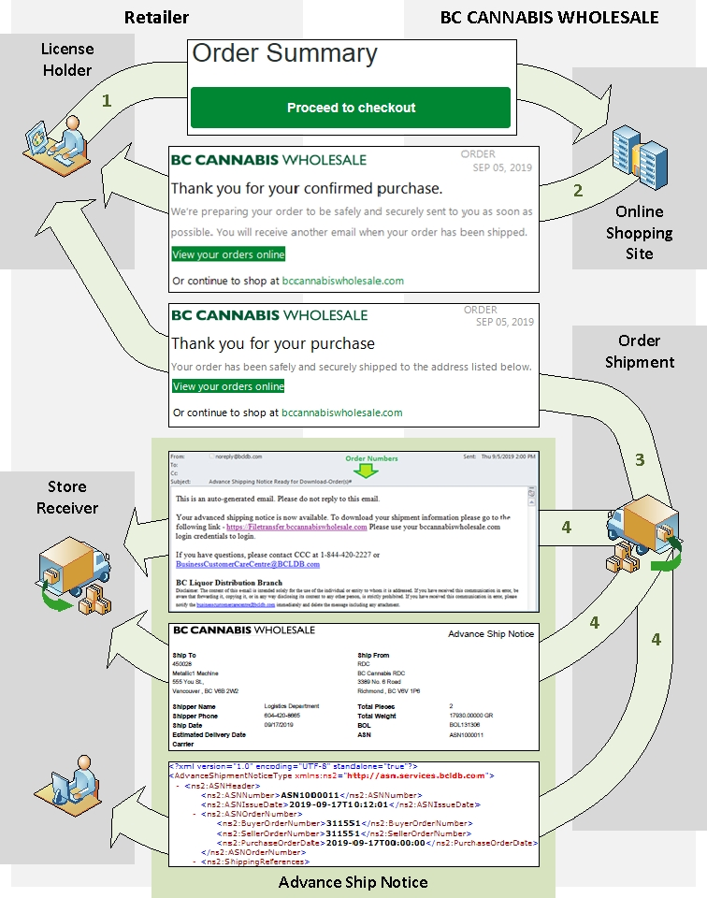

# ASN Delivery

## eMail Notification

When the ASN is ready for download, an eMail notification is sent to the primary contact associated with the customer license. This is may or may not be the same email address associated with the customer’s online shopping account.

The eMail notification will:

* List the order numbers to which the ASN pertains in the eMail subject line
* Provide a link from where to download the ASN

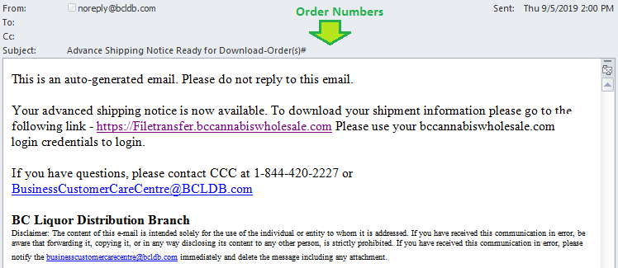

## ASN Download

Click on the link in the eMail or go directly to <https://filetransfer.bccannabiswholesale.com> . Log in with the same credentials used to create the order.

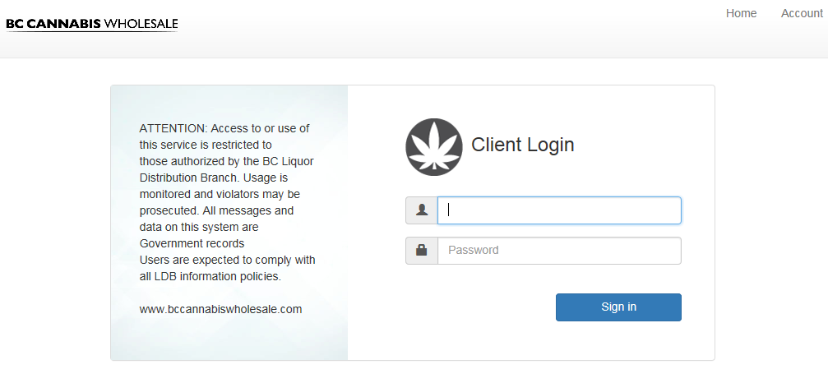

You will see folders for all licenses assigned to your account. If a license folder is missing, no ASN has yet been generated for that license.

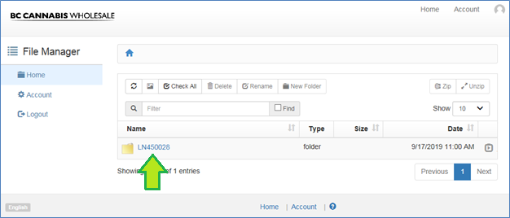

Click on the license number to open the folder.

**🡪Tip:** Make sure you click on the license number, not in the blank space next to it.

You will see a number of folders:

* PDF – For human readable ASNs
* XML – For data file ASNs intended for integration with POS systems

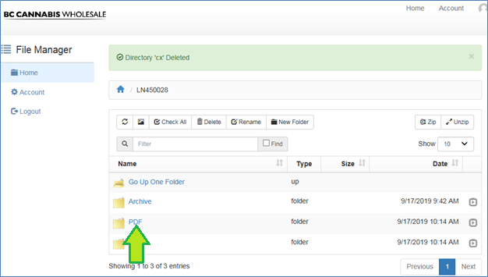

Click on PDF to open that folder.

**🡪Tip:** Make sure you click on the word “PDF”, not in the blank space next to it.

You will see any available ASN’s listed

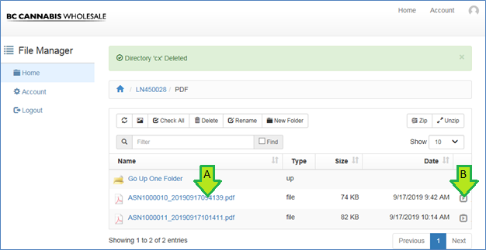

There are two options to view the ASN:

1. Click on the ASN file name to open it directly
2. Download the ASN file to your computer

B. To **download** the ASN file to your computer, click on the to the far right to show the “Download” button, then click “Download”.

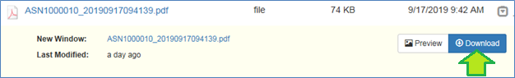

To **delete** the ASN file, click on the row (not the filename) to select the file, then click “Delete” above.

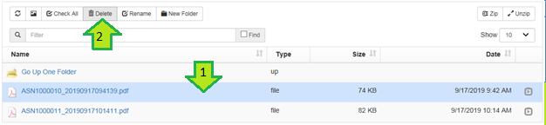

### Caveats

1. Do not change account settings through this site

The web site has an “Account” button at the top right of the page. This will display basic account information. However, changes made here have no effect. Any account changes, such as password changes, should be made through the BC Cannabis Wholesale shopping portal.

2. Do not upload files

The site does allow the customer to upload files. There is no reason for the customer to do so and customers should not use this site to upload files at this time.

3. Archive folder is temporary

There is currently an archive folder containing copies of the ASN files posted to the XML and PDF folders. This folder will be removed in the future. Customer should not rely on files being available through this folder.

4. Deletions are permanent

Any file deleted from the server will be permanently deleted. The CCC has a process to recreate ASN files for the customer if necessary, but this process is subject to IT resource availability.

Any folders deleted will be recreated by the system when the next ASN is created. However, any files contained in the deleted folders will not be restored unless specifically requested from the CCC.

## ASN Information & Documents

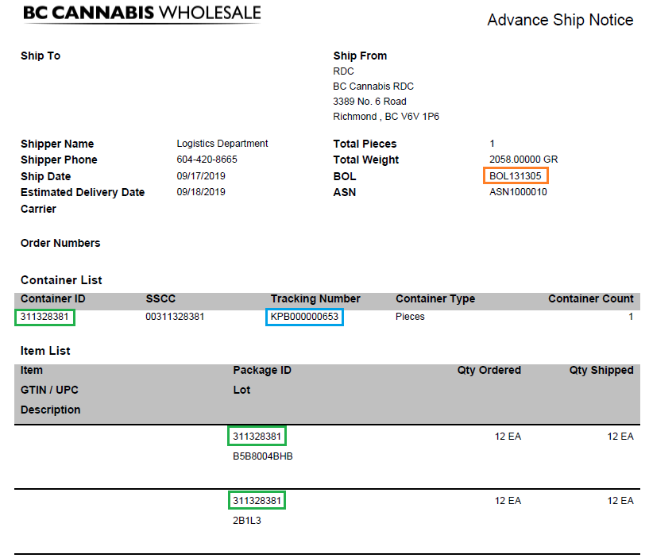

* The BOL number references the paper BOL
* The Tracking Number links the physical package to the ASN.
* The Container ID links the shipping container from the “Container List” to items in the “Item List”
* The Total Pieces refers to the number of shipping units (pallets for LTL, master cases for parcel carriers). Future versions of the ASN will include the master case count of the shipment.
* Quantiles are expressed in Eaches (retail units). Future versions of the ASN will include master case quantities.
* The same item may appear on multiple lines if ordered on multiple orders, sourced from multiple lots, o packaged in multiple ship units.
* SSCC is reserved for future use.

# Shipping Labels

## Parcel Carriers

Shipments delivered via parcel carriers, have a shipping label on each master case and each has a unique tracking number referenced in the ASN container list.

|  |  |
| --- | --- |
| Shipping Label | Context |
|  |  |

## LTL Carriers

Shipments delivered via LTL carrier have one shipping label per pallet. Each pallet has a unique Tracking Number referenced in the ASN.

|  |  |
| --- | --- |
| Shipping Label | Context |
|  |  |